## Java Core：

* 1. What is a static method in java?
  2. Can you change any instance method into a static method? Explain

1. 1. Abstract class versus an interface.
   2. Assuming we have an abstract calss that has 3 abstract methods, we have a child that implements only 2 of the 3 abstract methods and I would like my code to compile, what are my options?
2. Method override versus method overload
3. What is BigDecimal and why we need it in java?
4. 1. Checked vs. unchecked exception?
   2. Can we catch a runtime exception?
   3. What are the ways to handle a checked exception?
5. Given the following statements explain the execution order for the cases below:

|  |  |
| --- | --- |
| **try{ … }catch(Exception e){ … }finally{ … }** | |
| Case | Explanation |
| Exception occurs in the try block |  |
| Everything executes successfully in the try block |  |
| A return statement in the try block |  |
| A "System.exit()" in the try block |  |
|  |  |

1. 1. What is a HashMap?
   2. Explain how HashMap works internally
   3. What is the hash code used for?
   4. What happens when 2 keys have the same hashcode?
2. What would be the effect on a HashMap if you override the hash code function to always return 1?
3. HashMap versus HashTable
4. Given the following instructions, explain how would you return the 3rd element from the end of a single LinkedList?
   1. You are positioned on the head of a single linked list.
   2. You do not know the size of the list, nor have the ability to get it.
   3. You can traverse the list only once.
5. Explain differences between implementing Runnable versus extending Thread?
6. Deadlock versus starvation?
7. Consider an existing single threaded program that you have to convert to a multithreaded one.Explain the following:
   1. What are the rules of thumb/best practices to follow when doing such conversion
   2. Problems we can run into(consider locks, memory usage, synchronization, problem solving etc).
8. What is a memory leak in Java and how can you on purpose achieve a memory leak in a given program?
9. What is and how does the garbage collection work? Can you explicitly call garbage collector form your program?
10. Explain how the JVM memory is divided? Explain the different sections and their purpose.

## Sql:

Please use the below tables to write the following queries:

|  |  |  |  |  |
| --- | --- | --- | --- | --- |
| Employee |  |  |  |  |
| ID | Department\_ID | First\_Name | Last\_name | Salary |
| 1 | 1 | Johanna | Phillips | 10 |
| 2 | 3 | John | Lewis | 20 |
| 3 | 9 | Kurt | Nilson | 30 |
| 4 | 9 | Michael | Cheney | 40 |
| 5 | 10 | George | Martin | 50 |

|  |  |  |
| --- | --- | --- |
| Department |  |  |
| ID | Parent\_Department\_ID | Name |
| 1 | NULL | HR |
| 2 | NULL | ACCOUNTING |
| 3 | NULL | IT |
| 4 | 3 | NETWORK ADMIN |
| 5 | 3 | DATABASE |
| 6 | 5 | DBAS |
| 7 | 5 | SQL DEVS |
| 8 | 3 | JAVA DEVS |
| 9 | 8 | JAVA SENIORS |
| 10 | 8 | JAVA JUNIORS |

1. Return the total number of employees in the organization using the two above tables
2. Return the Department Name and Number of employees in each department using the two above tables
3. Return the Department Names with more than 10 employees using the two above tables
4. Return the Department and the Highest paid employee Name in each department.
5. Return one row with the 3rd best paid person in the company
6. Write the stored procedure to return TURE or FLASE if an Employee Name is part of a Department OR Subdepartment  
   HINT:execute Check\_Emp(‘George’,’Martin’,’IT’)should return TRUE as ‘JAVA JUNIORS’< ‘JAVA DEVS’ < IT
7. Update the Salary in the Empolyee table using the value in the below Promotion table

|  |  |
| --- | --- |
| Promotion | |
| Employee\_ID | New\_Salary |
| 1 | 80 |
| 3 | 90 |

## AlgorithmE:\MyData\移民\工作\interview\CGI\IMG_20180928_141203.jpg

## Design pattern

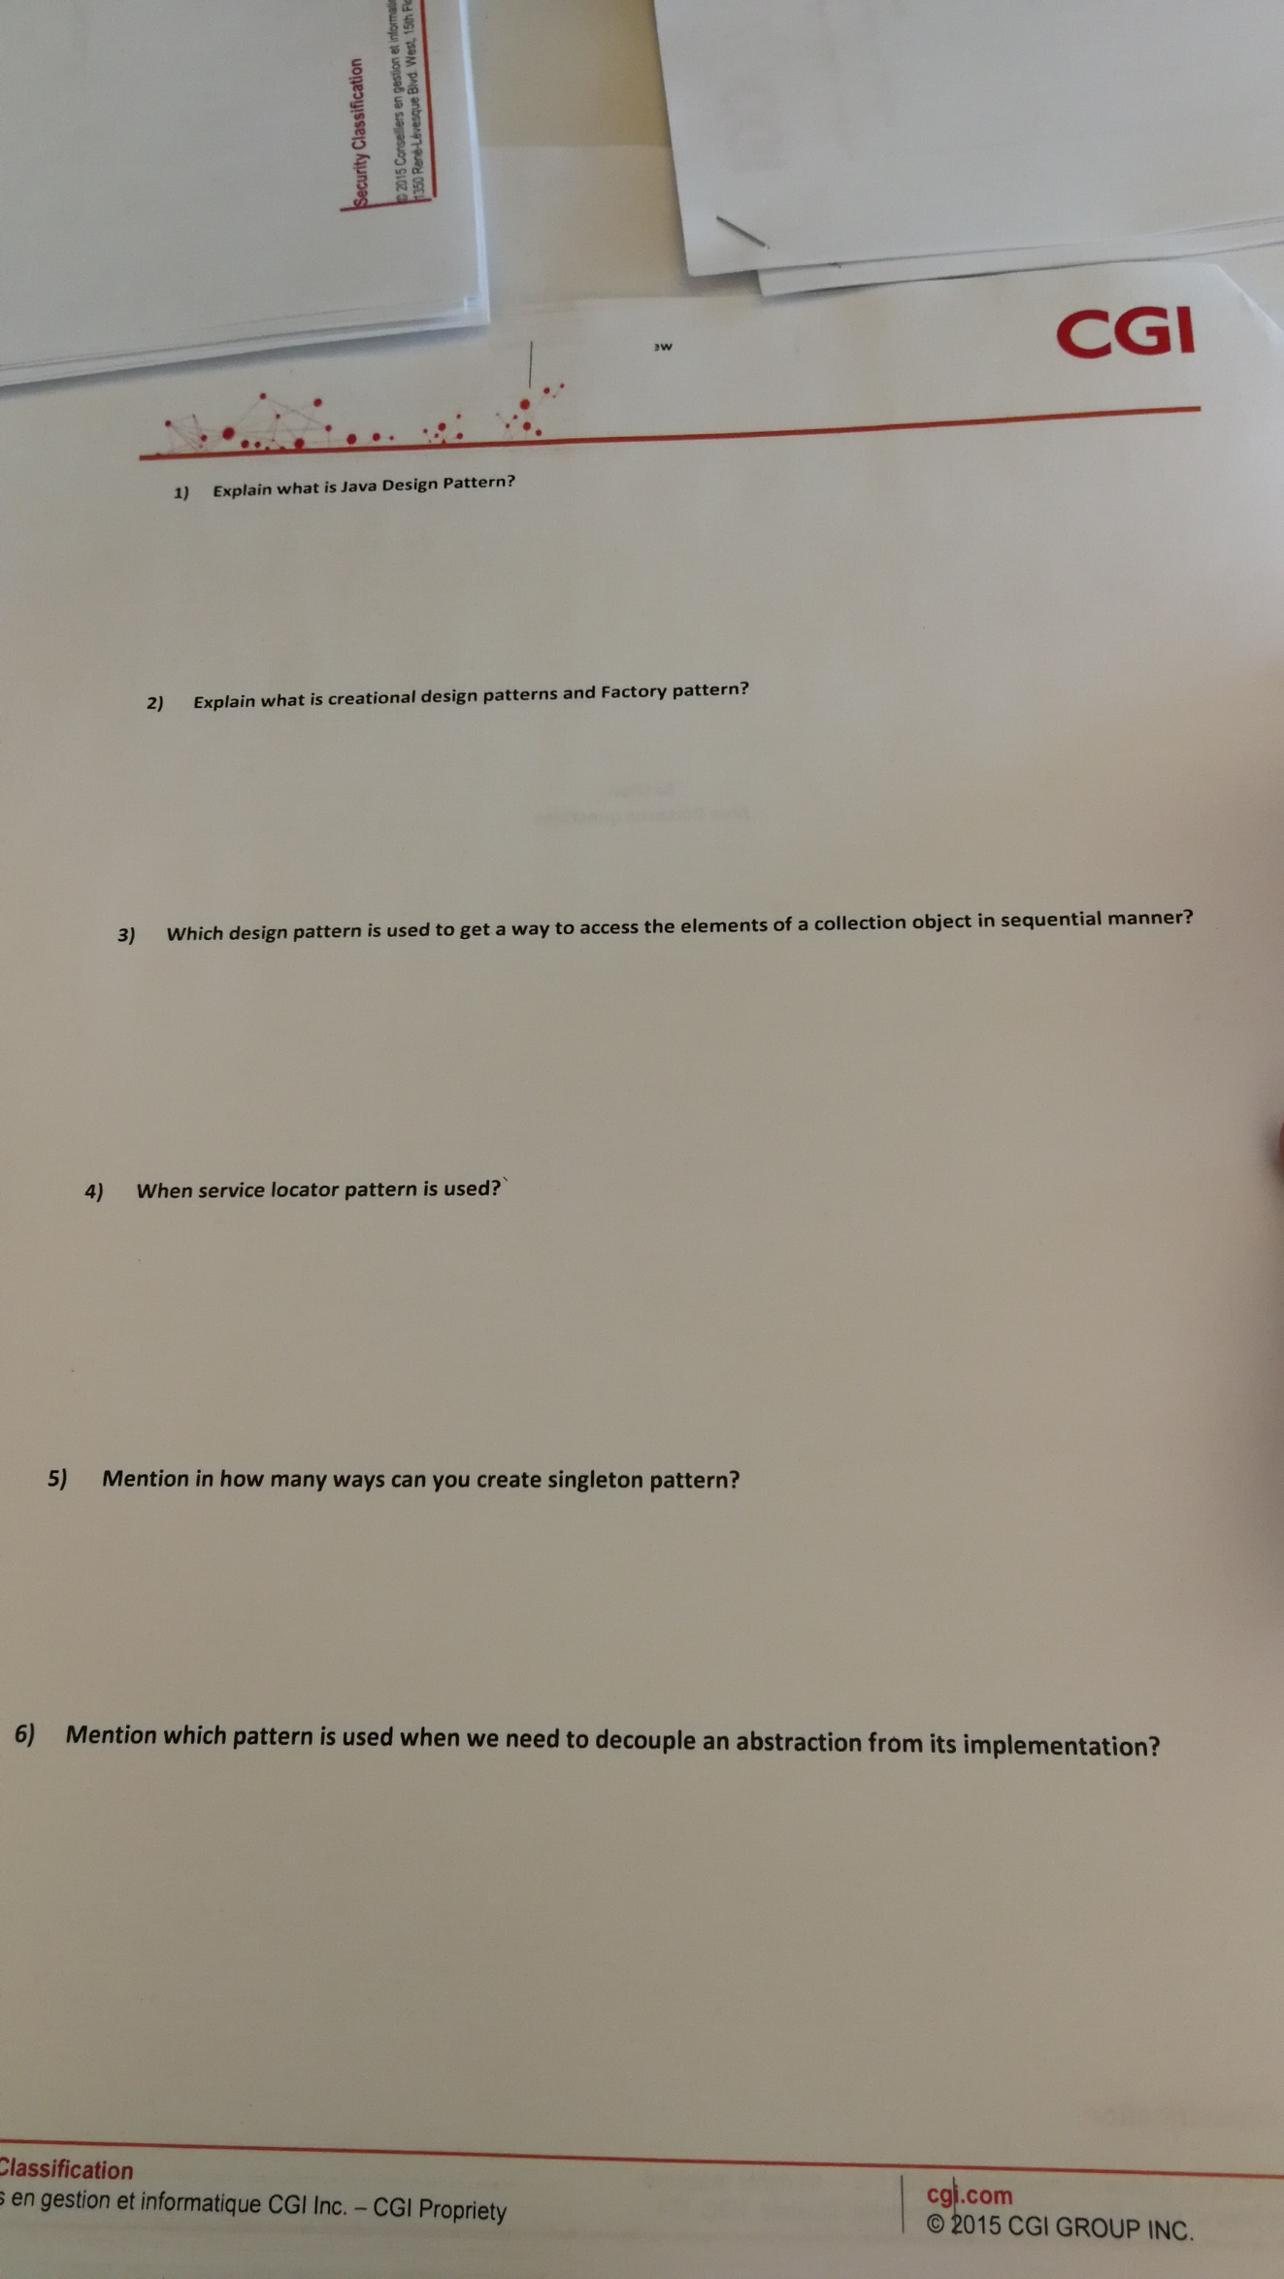

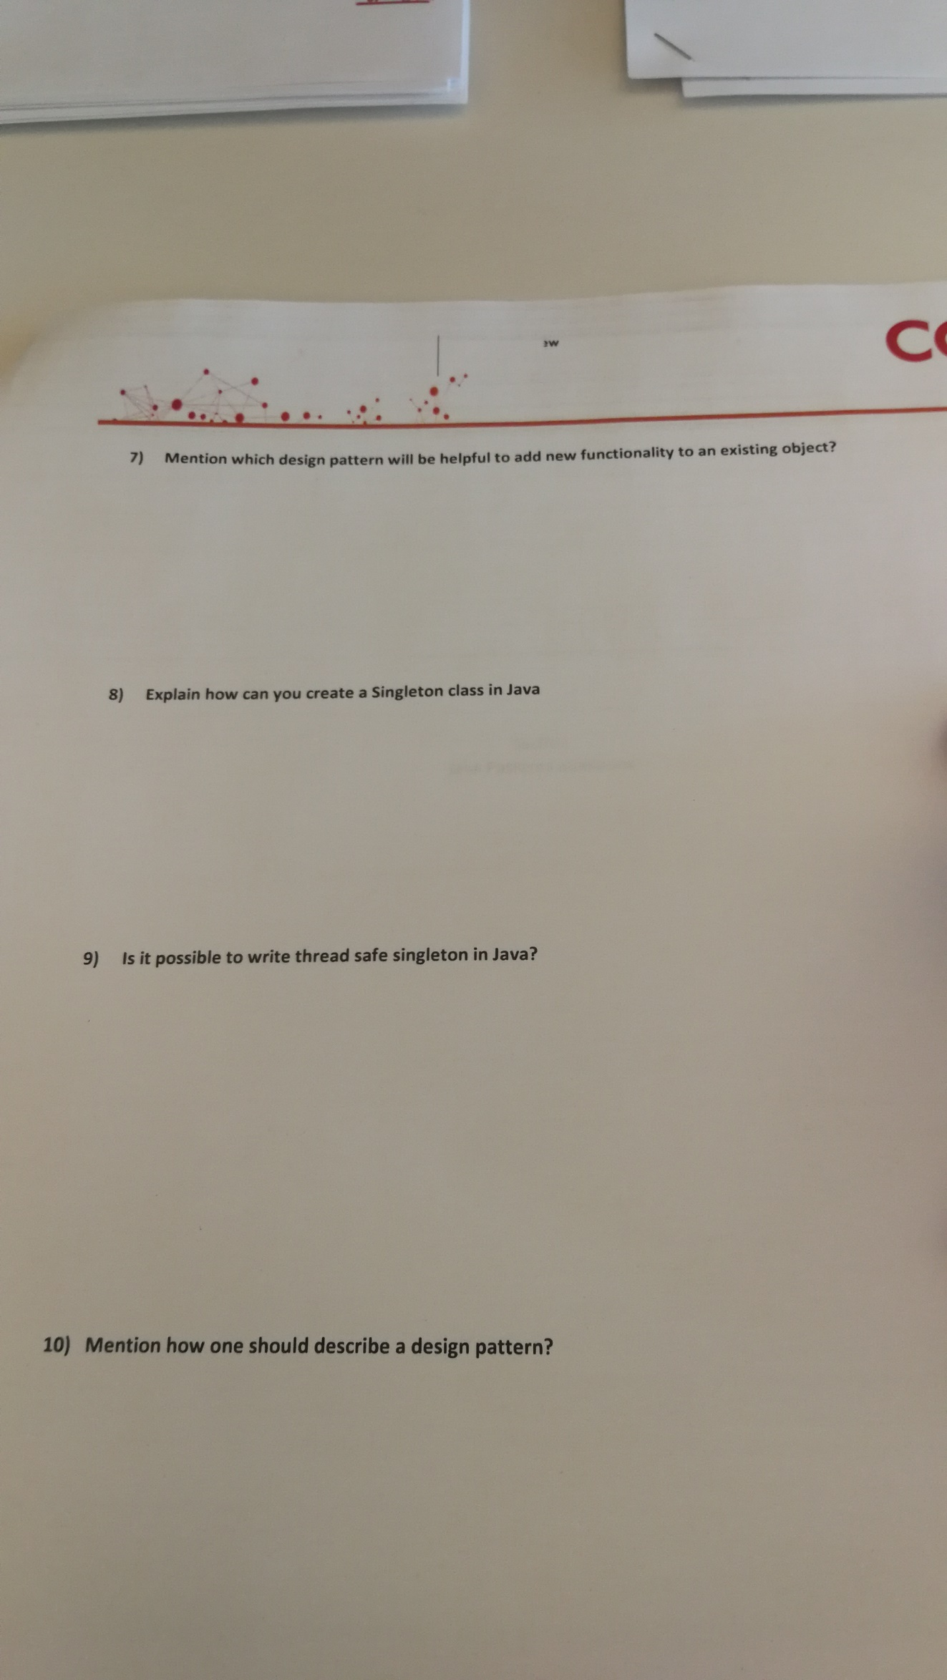

## Unix

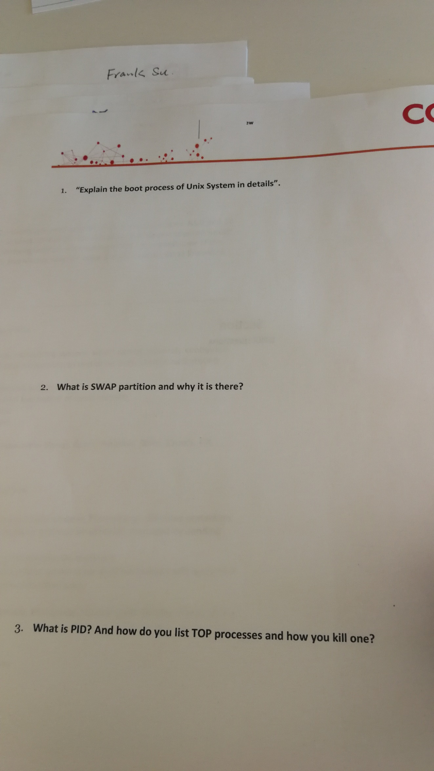

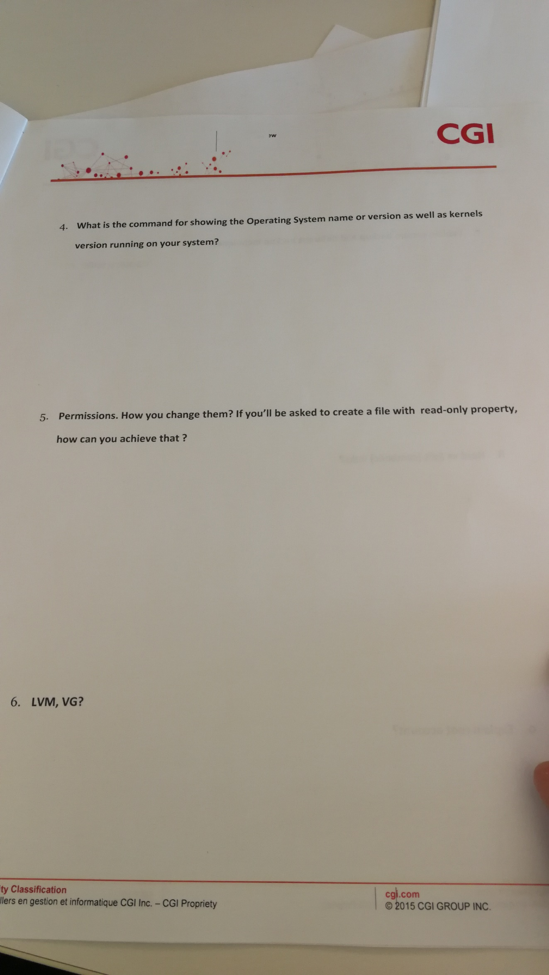

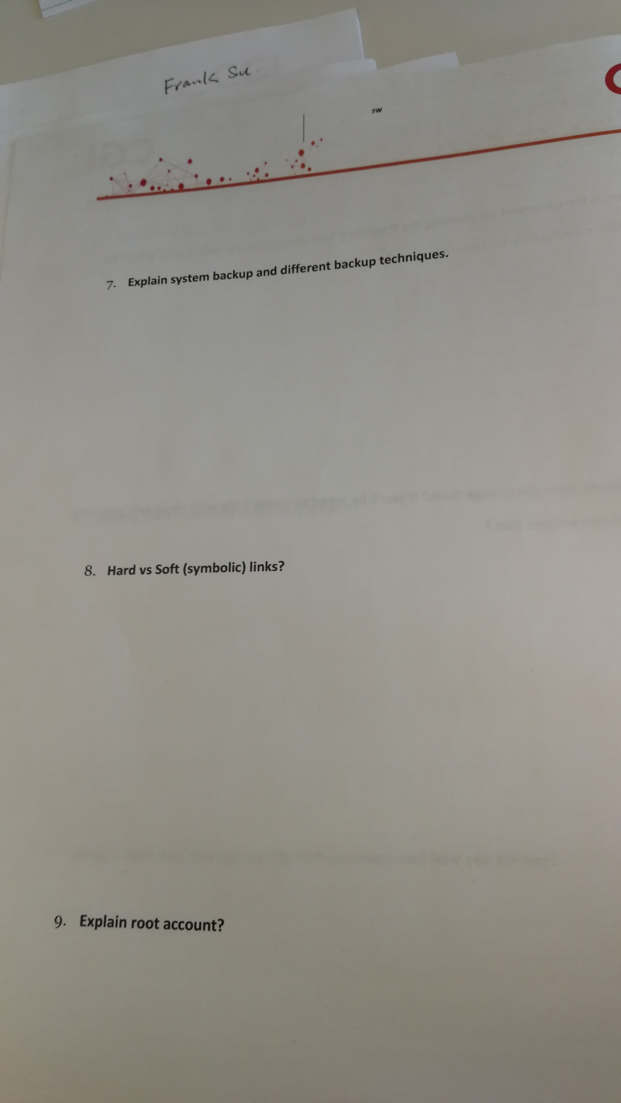

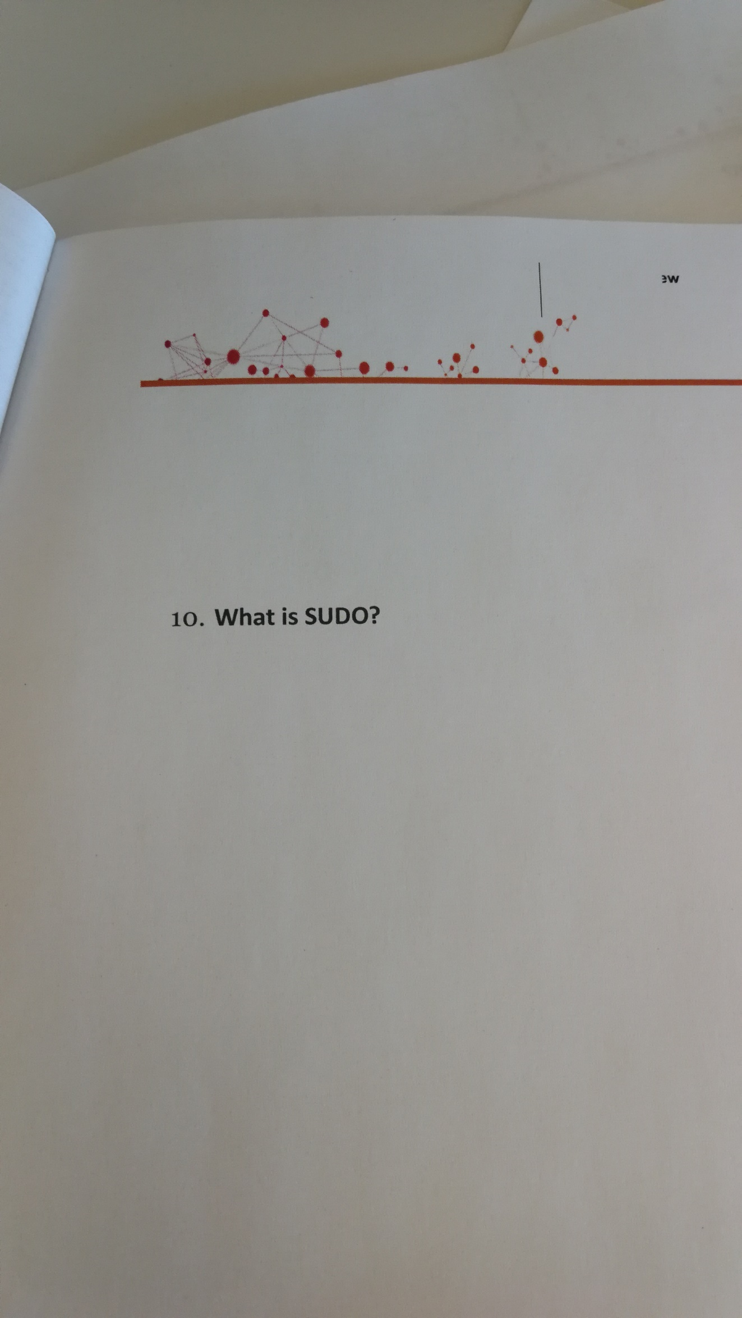

## Javascript

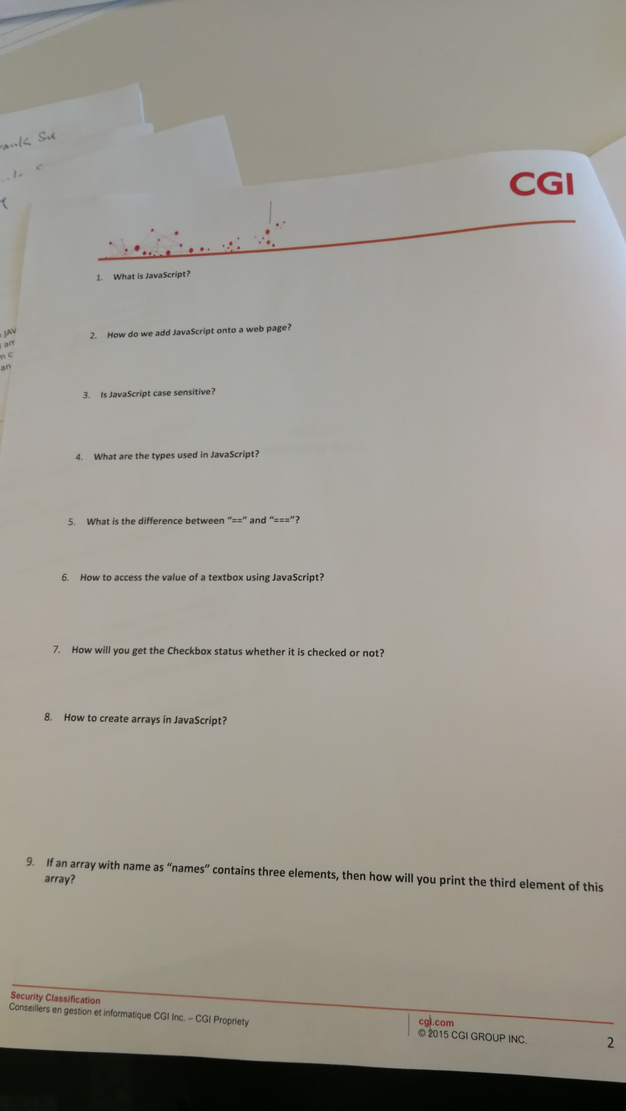

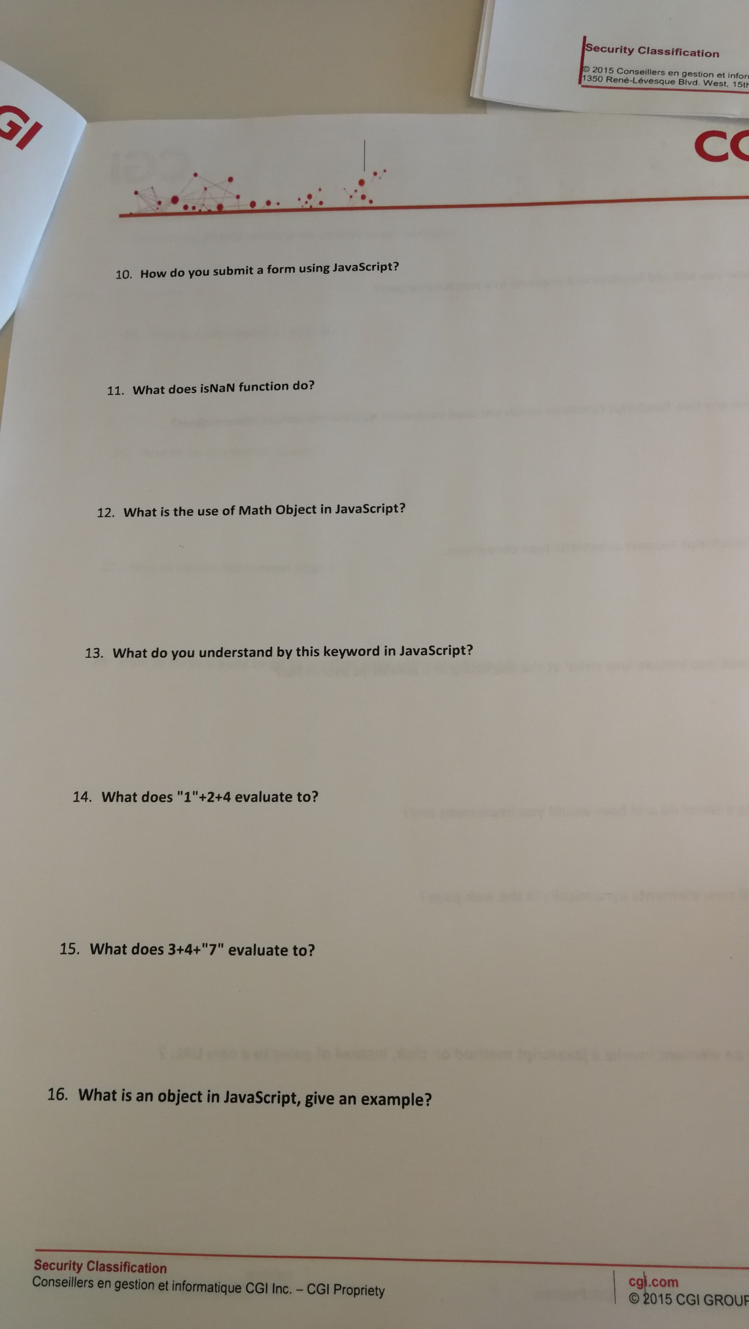

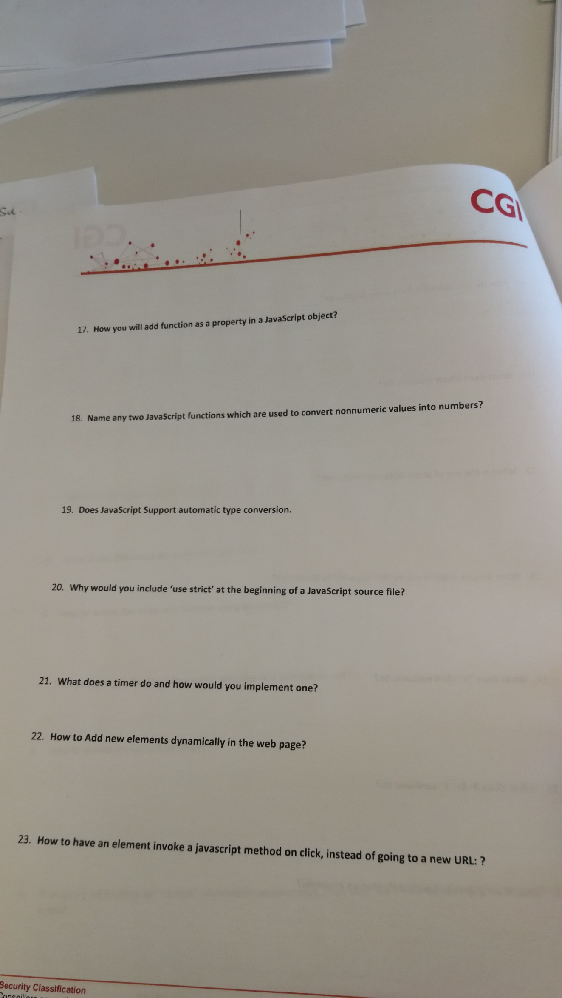

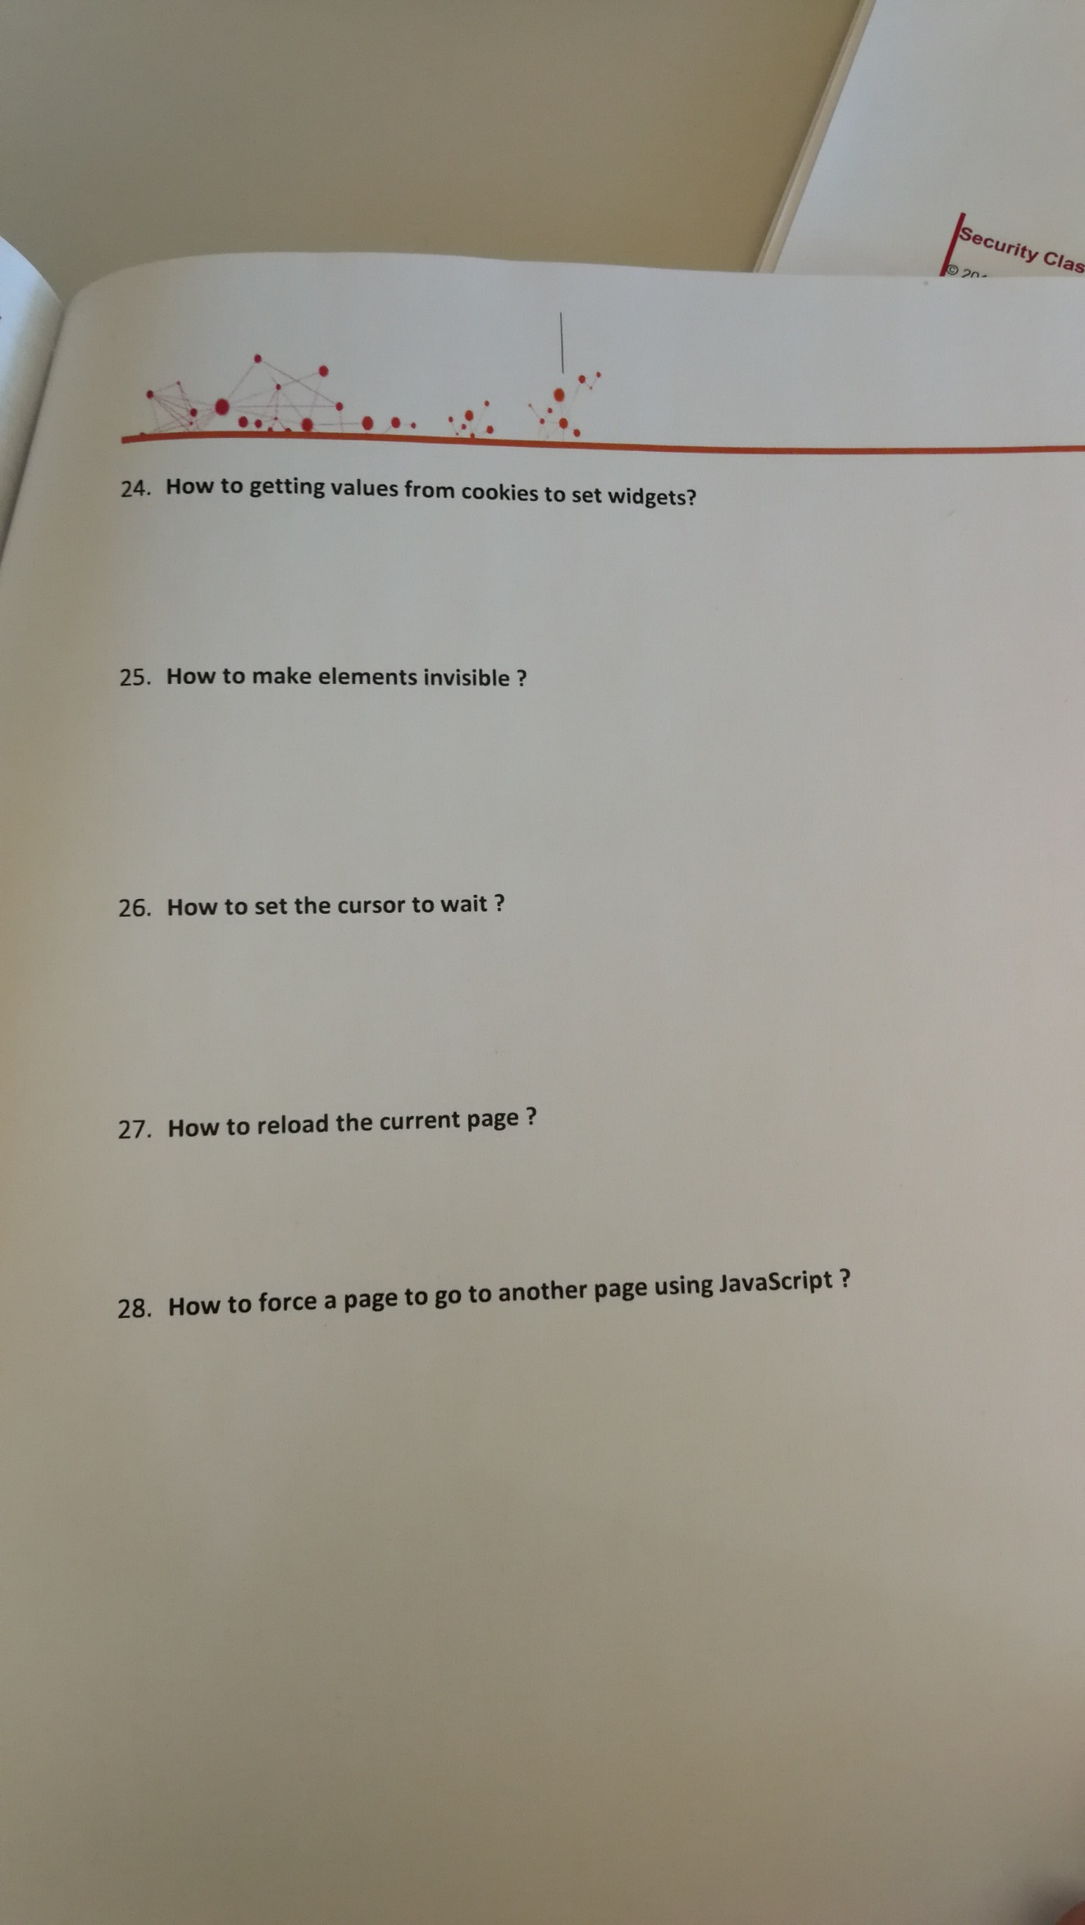

## HTML5

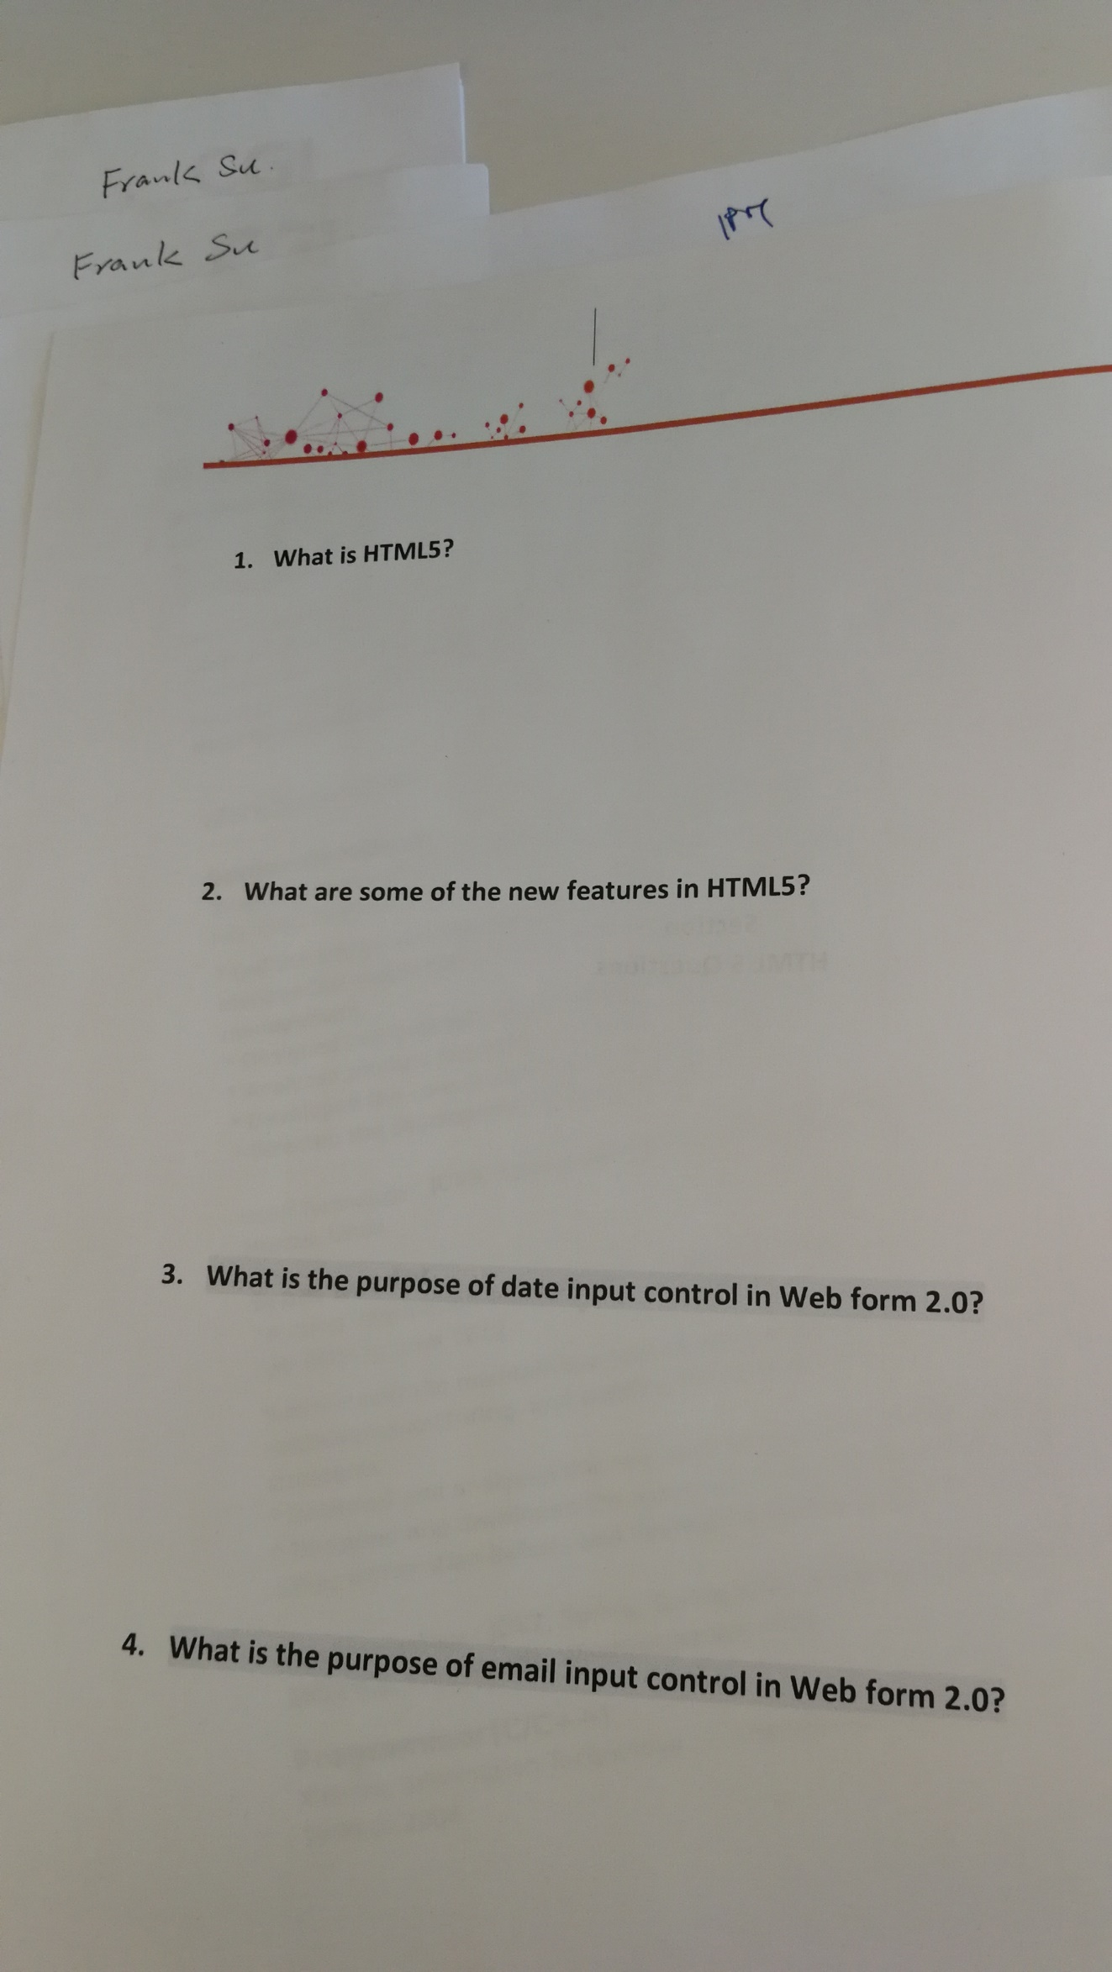

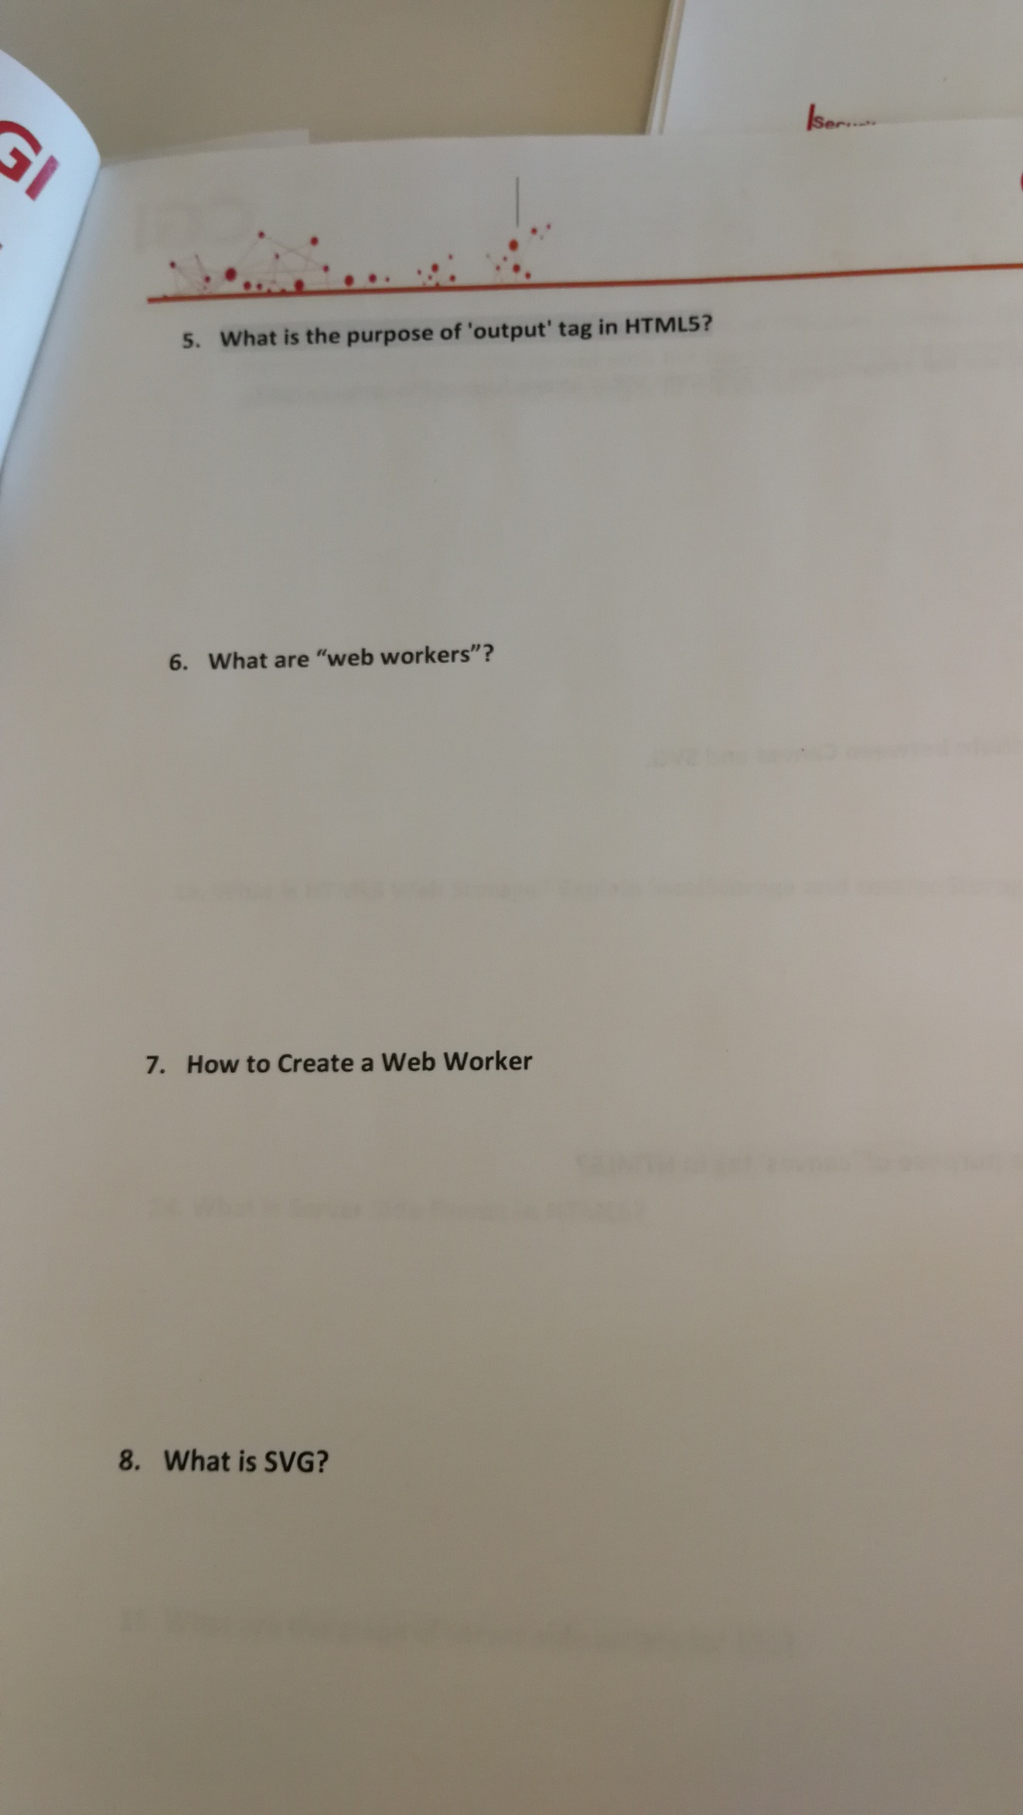

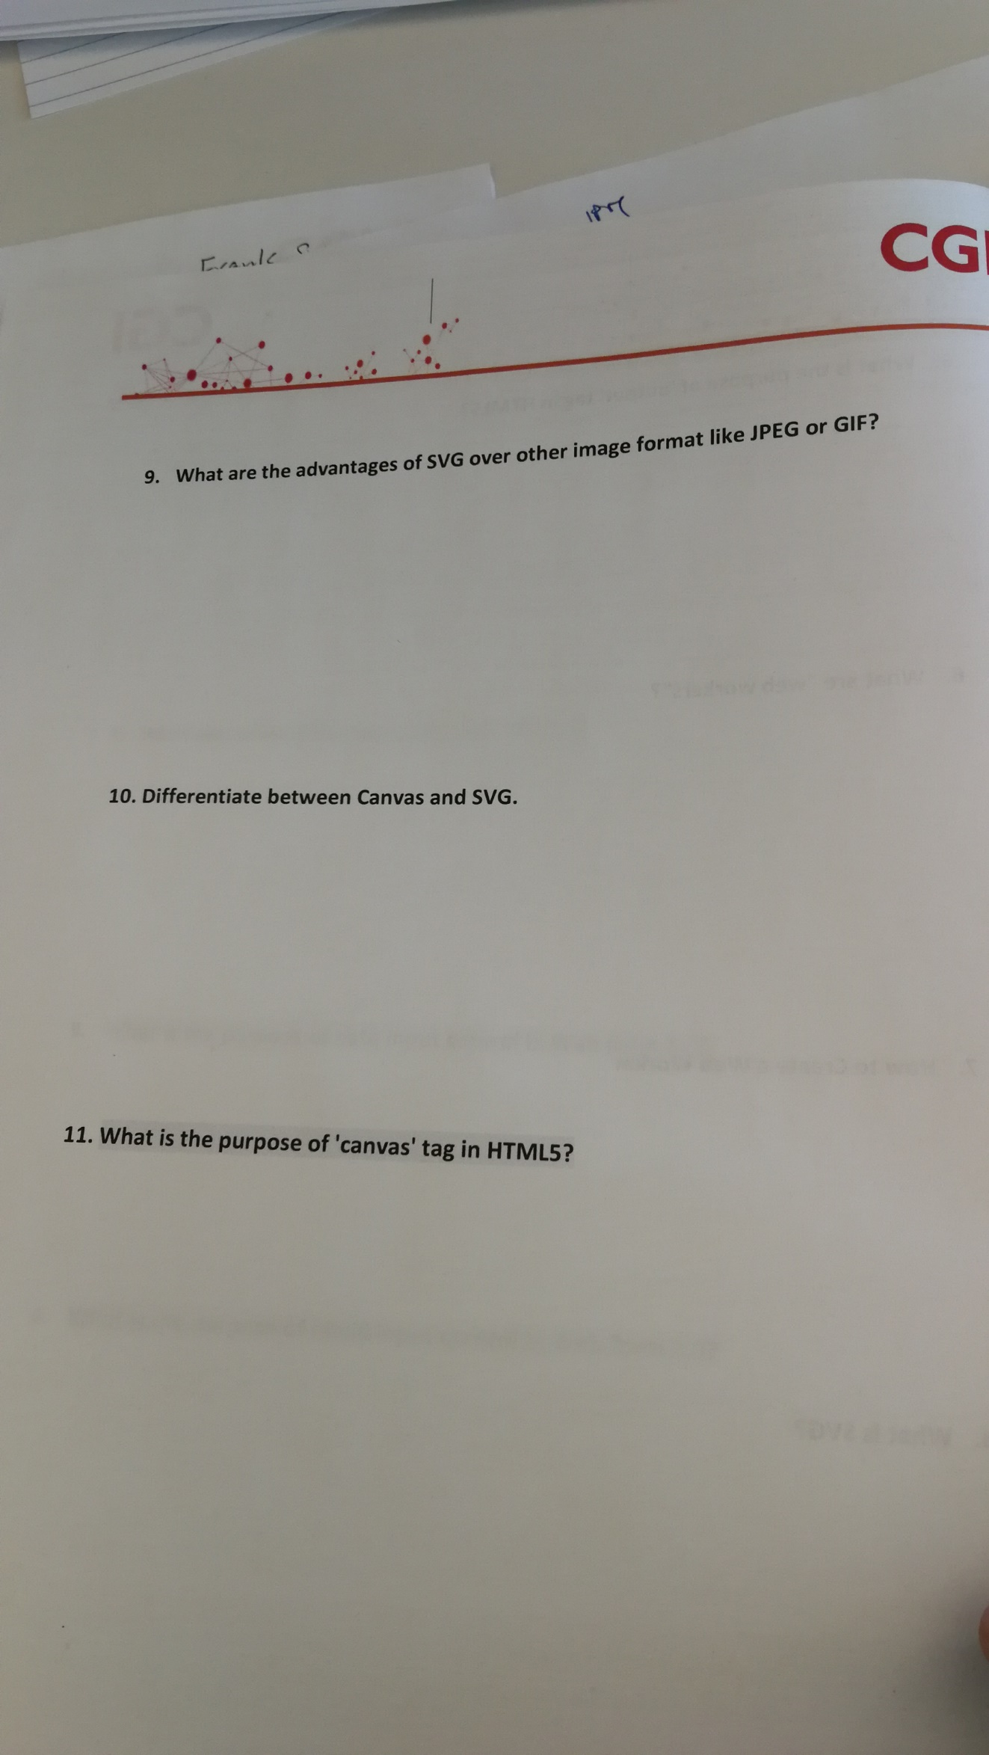

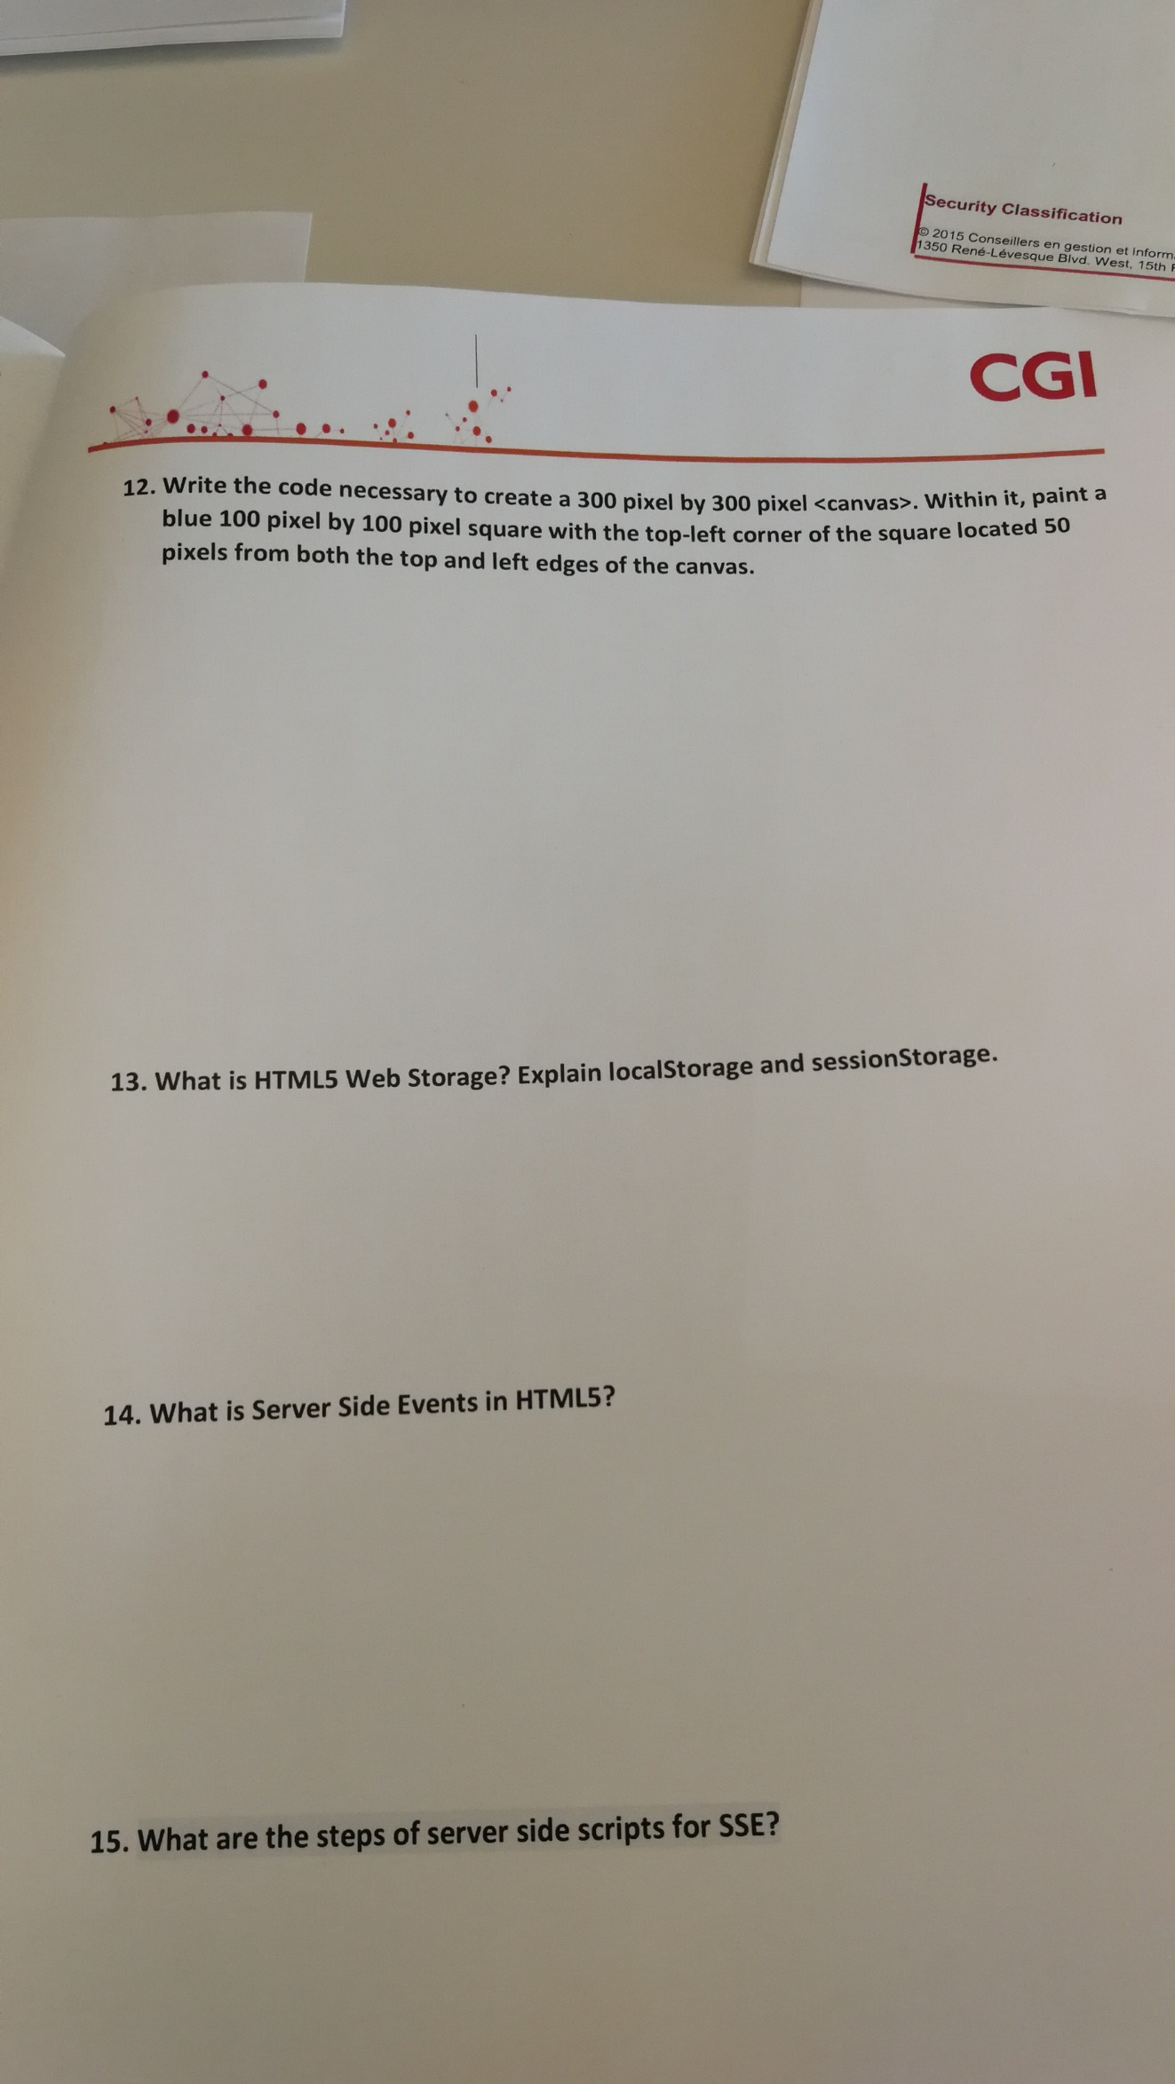

## Python

